**ER Diagram: Supershop Management System**

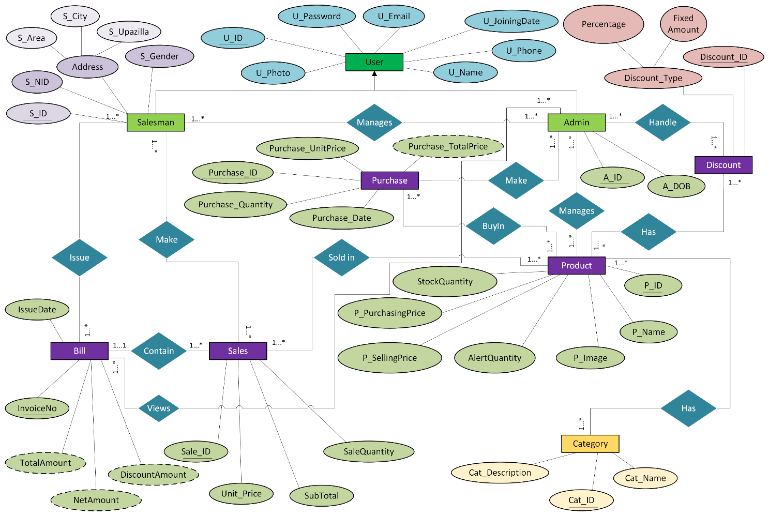

**Normalization**

|  |  |  |  |  |
| --- | --- | --- | --- | --- |
| |  |  | | --- | --- | | User / Admin / Salesman >> Occur Inheritance | | | User: | U_ID, U_Password, U_Name, U_Email, U_Phone, U_Image, U_JoiningDate | |
| |  |  | | --- | --- | | Admin Manages Salesman: (m-m) | | | 1NF | 1. A_ID, A_DOB, S_ID, S_NID, S_Gender, S_Area, S_Upazilla, S_City. | | 2NF | 1. A_ID(PK + FK) ref ‘User’, A_DOB 2. S_ID(PK + FK) ref ‘User’, S_NID, S_Gender, S_Area, S_Upazilla, S_City 3. A_ID(PK), S_ID(FK) | | 3NF | No transitive dependency | |
|  |
| |  |  | | --- | --- | | Admin Handle Discount: (m-m) | | | 1NF | 1. A_ID, A_DOB, Discount_ID, Percentage, FixedAmount | | 2NF | 1. A_ID, A_DOB, 2. Discount_ID, Percentage, FixedAmount. 3. A_ID(PK), Discount_ID(FK). | | 3NF | No transitive dependency | |
|  |
| |  |  | | --- | --- | | Admin Manages Product: (m-m) | | | 1NF | 1. A_ID, A_DOB, P_ID, P_Name, P_Image, P_PurchasingPrice, P_SellingPrice, P_StockQunatity, P_AlertQuantity | | 2NF | 1. A_ID, A_DOB, 2. P_ID, P_Name, P_Image, P_PurchasingPrice, P_SellingPrice, P_StockQunatity, P_AlertQuantity. 3. A_ID(PK), P_ID(FK). | | 3NF | No transitive dependency | |
|  |
| |  |  | | --- | --- | | Admin Make Purchase: (m-m) | | | 1NF | 1. A_ID, A_DOB, Purchase_ID, Purchase_Quantity, Purchase_UnitPrice, Purchase_TotalPrice, Purchase_Date. | | 2NF | 1. A_ID(PK), A_DOB 2. Purchsase_ID(PK), Purchase_Quantity, Purchase_UnitPrice, Purchase_TotalPrice, Purchase_Date.A_ID(PK), P_ID(FK). 3. A_ID(PK), P_ID(FK). | | 3NF | No transitive dependency | |

|  |  |  |  |  |  |  |  |  |
| --- | --- | --- | --- | --- | --- | --- | --- | --- |
| |  |  | | --- | --- | | Admin Views Bill: (m-m) | | | 1NF | 1. A_ID, A_DOB, InvoiceNo, IssueDate | | 2NF | 1. A_ID, A_DOB 2. InvoiceNo(PK), IssueDate. 3. A_ID(PK), P_ID(FK). | | 3NF | No transitive dependency | |
|  |
| |  |  | | --- | --- | | Product Has Category: (m-m) | | | 1NF | 1. P_ID, P_Name, P_Image, P_PurchasingPrice, P_SellingPrice, P_StockQunatity, P_AlertQuantity, Cat_ID, Cat_Name, Cat_Description. | | 2NF | 1. P_ID(PK), P_Name, P_Image, P_PurchasingPrice, P_SellingPrice, P_StockQunatity, P_AlertQuantity 2. Cat_ID(PK), Cat_Name, Cat_Description. 3. P_ID(pk), Cat_ID(FK) | | 3NF | No transitive dependency | |
|  |
| |  |  | | --- | --- | | Product Has Discount: (m-m) | | | 1NF | 1. P_ID, P_Name, P_Image, P_PurchasingPrice, P_SellingPrice, P_StockQunatity, P_AlertQuantity, Discount_ID, Percentage, FixedAmount | | 2NF | 1. P_ID(PK), P_Name, P_Image, P_PurchasingPrice, P_SellingPrice, P_StockQunatity, P_AlertQuantity. 2. Discount_ID(PK), Percentage, FixedAmount . 3. P_ID(pk), Discount_ID(FK) | | 3NF | No transitive dependency | |
|  |
| |  |  | | --- | --- | | Product Buy In Purchase: (m-m) | | | 1NF | 1. P_ID, P_Name, P_Image, P_PurchasingPrice, P_SellingPrice, P_StockQunatity, P_AlertQuantity, Purchsase_ID, Purchase_Quantity, Purchase_UnitPrice, Purchase_TotalPrice, Purchase_Date. | | 2NF | 1. P_ID(PK), P_Name, P_Image, P_PurchasingPrice, P_SellingPrice, P_StockQunatity, P_AlertQuantity. 2. Purchsase_ID, Purchase_Quantity, Purchase_UnitPrice, Purchase_TotalPrice, Purchase_Date. 3. P_ID(pk), Purchase_ID(FK) | | 3NF | No transitive dependency | |
|  |
| |  |  | | --- | --- | | Product Sold In Sale: (m-m) | | | 1NF | 1. P_ID, P_Name, P_Image, P_PurchasingPrice, P_SellingPrice, P_StockQunatity, P_AlertQuantity, Sale_ID, Unit_Price, Sale_Quantity, Sale_SubTotal. | | 2NF | 1. P_ID(PK), P_Name, P_Image, P_PurchasingPrice, P_SellingPrice, P_StockQunatity, P_AlertQuantity. 2. Sale_ID(PK), Unit_Price, Sale_Quantity, Sale_SubTotal. 3. P_ID(pk), Sale_ID(FK) | | 3NF | No transitive dependency. Same as 2NF | |

|  |  |  |  |  |  |  |  |  |
| --- | --- | --- | --- | --- | --- | --- | --- | --- |
| |  |  | | --- | --- | | Salesman Make Sales: (M-M) | | | 1NF | 1. S_ID, S_NID, S_Gender, S_Area, S_Upazilla, S_City, Sale_ID, Unit_Price, Sale_Quantity, Sale_SubTotal. | | 2NF | 1. S_ID(PK), S_NID, S_Gender, S_Area, S_Upazilla, S_City. 2. Sale_ID(PK), Unit_Price, Sale_Quantity, Sale_SubTotal. 3. S_ID(PK), Sale_ID(FK) | | 3NF | No transitive dependency. Same as 2NF | |
|  |
| |  |  | | --- | --- | | Salesman Issue Bill: (M-M) | | | 1NF | 1. S_ID, S_NID, S_Gender, S_Area, S_Upazilla, S_City, InvoiceNo(PK), IssueDate. | | 2NF | 1. S_ID(PK), S_NID, S_Gender, S_Area, S_Upazilla, S_City. 2. Sale_ID(PK), Unit_Price, Sale_Quantity, Sale_SubTotal. 3. S_ID(PK), InvoiceNO(FK). | | 3NF | No transitive dependency. Same as 2NF | |
|  |
| |  |  | | --- | --- | | Bill Contain Sale: (1-M) | | | 1NF | 1. InvoiceNo(PK), IssueDate, Sale_ID, Sale_Quantity, Unit_Price, SubTotal. | | 2NF | 1. InvoiceNo(PK), Sale_ID(FK), Sale_Quantity, Unit_Price, SubTotal. 2. InvoiceNo(PK), IssueDate | | 3NF | No transitive dependency. Same as 2NF | |
|  |

**Finalization**

1. A_ID(PK + FK) ref ‘User’, A_DOB
2. S_ID(PK + FK) ref ‘User’, S_NID, S_Gender, S_Area, S_Upazilla, S_City
3. A_ID(PK), S_ID(FK)
4. ~~A_ID(PK), A_DOB~~
5. Discount_ID(PK), Percentage, FixedAmount.
6. A_ID(PK), Discount_ID(FK).
7. ~~A_ID, A_DOB~~
8. P_ID(PK), P_Name, P_Image, P_PurchasingPrice, P_SellingPrice, P_StockQunatity, P_AlertQuantity.
9. A_ID(PK), P_ID(FK).
10. ~~A_ID(PK), A_DOB~~
11. Purchsase_ID(PK), Purchase_Quantity, Purchase_UnitPrice, Purchase_TotalPrice, Purchase_Date.A_ID(PK), P_ID(FK).
12. ~~A_ID(PK), P_ID(FK).~~
13. ~~A_ID, A_DOB~~
14. InvoiceNo(PK), IssueDate.
15. ~~A_ID(PK), P_ID(FK).~~
16. ~~P_ID(PK), P_Name, P_Image, P_PurchasingPrice, P_SellingPrice, P_StockQunatity, P_AlertQuantity~~
17. Cat_ID(PK), Cat_Name, Cat_Description.
18. P_ID(pk), Cat_ID(FK)
19. ~~P_ID(PK), P_Name, P_Image, P_PurchasingPrice, P_SellingPrice, P_StockQunatity, P_AlertQuantity.~~
20. ~~Discount_ID(PK), Percentage, FixedAmount .~~
21. P_ID(pk), Discount_ID(FK)
22. ~~P_ID(PK), P_Name, P_Image, P_PurchasingPrice, P_SellingPrice, P_StockQunatity, P_AlertQuantity.~~
23. ~~Purchase_ID, Purchase_Quantity, Purchase_UnitPrice, Purchase_TotalPrice, Purchase_Date.~~
24. P_ID(pk), Purchase_ID(FK)
25. ~~P_ID(PK), P_Name, P_Image, P_PurchasingPrice, P_SellingPrice, P_StockQunatity, P_AlertQuantity.~~
26. Sale_ID(PK), Unit_Price, Sale_Quantity, Sale_SubTotal.
27. P_ID(pk), Sale_ID(FK)
28. ~~S_ID(PK), S_NID, S_Gender, S_Area, S_Upazilla, S_City.~~
29. ~~Sale_ID(PK), Unit_Price, Sale_Quantity, Sale_SubTotal.~~
30. S_ID(PK), Sale_ID(FK)
31. ~~S_ID(PK), S_NID, S_Gender, S_Area, S_Upazilla, S_City.~~
32. ~~Sale_ID(PK), Unit_Price, Sale_Quantity, Sale_SubTotal.~~
33. S_ID(PK), InvoiceNO(FK).
34. InvoiceNo(PK), Sale_ID(FK), Sale_Quantity, Unit_Price, SubTotal.
35. ~~InvoiceNo(PK), IssueDate~~

**Final Table:**

1. **Admin:** A_ID(PK + FK) ref ‘User’, A_DOB
2. **Salesman:** S_ID(PK + FK) ref ‘User’, S_NID, S_Gender, S_Area, S_Upazilla, S_City
3. **AdminSalesman:** A_ID(PK), S_ID(FK)
4. **Discount:** Discount_ID(PK), Percentage, FixedAmount.
5. **AdminDiscount:** A_ID(PK), Discount_ID(FK).
6. **Product:** P_ID(PK), P_Name, P_Image, P_PurchasingPrice, P_SellingPrice, P_StockQunatity, P_AlertQuantity.
7. **AdminProduct:** A_ID(PK), P_ID(FK).
8. **Purchase:** Purchase_ID(PK), Purchase_Quantity, Purchase_UnitPrice, Purchase_TotalPrice, Purchase_Date.
9. **Bill:** InvoiceNo(PK), IssueDate.
10. **Category:** Cat_ID(PK), Cat_Name, Cat_Description.
11. **ProductCategory:** P_ID(pk), Cat_ID(FK)
12. **ProductDiscount:** P_ID(pk), Discount_ID(FK)
13. **ProductPurchase:** P_ID(pk), Purchase_ID(FK)
14. **Sale:** Sale_ID(PK), Unit_Price, Sale_Quantity, Sale_SubTotal.
15. **ProductSale:** P_ID(pk), Sale_ID(FK)
16. **SalesmnSale:** S_ID(PK), Sale_ID(FK)
17. **SalesmanBill:** S_ID(PK), InvoiceNO(FK).
18. **BillSale:** InvoiceNo(PK), Sale_ID(FK), Sale_Quantity, Unit_Price, SubTotal.